User Manual for dot69

System Requirement:

* Any text editor
* Python 3.6
* Compiler.py

To create a program first you need to:

* Make a new folder
* Put the compiler.py in the folder that you created

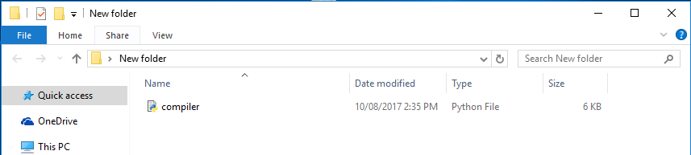

Simple Hello World:

* Open notepad or any IDE
* Save the file with an extension “.69”
* Save as type: “All types”

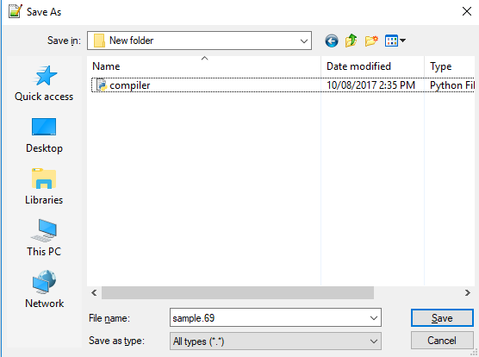

* You can now start writing the program (Refer to the documentation of syntax)

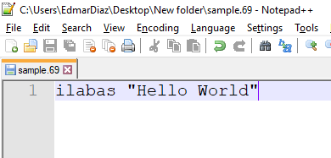

To Compile:

* Go to command prompt
* Go to the directory and go to the folder you created
* To run the program type: py compiler.py filename.69

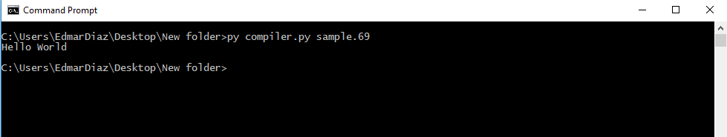

* Congratulations you successfully run dot69 program